**Eastern Mediterranean University**

**Department of Computer Engineering**

**CMSE321- Software Requirements Analysis and Specification**



**Instructor: PROF. DR. HADİ IŞIK AYBAY**

**Lab Coordinator: NADA KOLLAH**

**PHARMACY INFORMATION SYSTEM**

**Final Report**

**Group 21**

**17300009 ZEYNEP PELİN ÇOLAK**

**FALL SEMESTER 2022-2023**

**OUTLINE**

* COVER PAGE
* OUTLINE

1. INTRODUCTION

1.1.KEY WORDS

1.2.WHY IS THIS SYSTEM NEEDED?

1.3.HOW DOES IT FIT INTO THE ENVIRONMENT?

1.4. SYSTEM SCOPE

1. PROJECT MANAGEMET

2.1.TIMELINE

2.2.WORK DISTRIBUTION

2.3.MEETING

1. SOLUTION METHODOLOGY

3.1.SYSTEM ARCHITECTURE DIAGRAM

3.2.MODULAR HIERARCY DIAGRAM

1. FUNCTIONAL REGUIREMENT
2. NON-FUNCTIONAL / QUALITY REQUIREMENTS
3. USER INTERFACE

6.1. USER LOGIN

6.2. HOME PAGE

6.3. NEW CUSTOMER INFORMATİON

6.4. STOCK MANAGEMENT

6.5. MEDİCİNE INFORMATION

6.6. NEW MEDICINE ADD

6.7. MEDICINE INFORMATION UPDATE

1. CONCLUSION
2. REFERENCES

**LIST OF FIGURE**

FİGURE 1:SYSTEM ARCHITECTURE DIAGRAM

FİGURE 2:MODULAR HIERARCY DIAGRAM

FİGURE 3:USER LOGIN SCREEN

FİGURE 4: HOME PAGE SCREEN

FİGURE 5: NEW COSTUMER İNFORMATION SCREEN

FİGURE 6:STOCK MANAGEMENT SCREEN

FİGURE 7: MEDICINE İNFORMATION SCREEN

FİGURE 8: NEW MEDICINE ADD SCREEN

FİGURE 9: MEDICINE INFORMATION UPDATE SCREEN

**LIST OF TABLE**

TABLE 1: TIME LINE

TABLE 2: FUNCTIONAL REQUIREMENT

1. **INTRODUCTION**

The pharmacy information system is a multi-functional system that allows pharmacists to maintain the supply and organization of drugs. The system helps decrease medication errors, increase patient safety, report drug usage, and track costs.

 Furthermore, the PIS helps clinical decision-making by alerting users about clinically important drug-drug interactions, drug allergies , and drug doses; it also evaluates patterns of drug use as well as other possible side effects of drugs. The PIS may operate as a separate and individual system or as part of a hospital information system, paired with the Computerized Physician Order Entry system . Accordingly, to ensure efficiency and effectiveness of these systems, evaluation of the PIS is extremely important; this system could ultimately influence the safety and quality of care.

**1.1. KEY WORDS**

Pharmacy, Medication, Patient, Treatment, Side Effect, Adding Medication, Updating Medication, Web Software, System

**1.2.WHY IS THIS SYSTEM NEEDED?**

Pharmacy information systems (PIS) covers drug use, drug stock and management activities in patient care. Hospital pharmacies have a wide range of information processing needs.Of drugs; Careful supervision of ordering, stocking and distribution, and keeping and keeping secure records to avoid medical errors, is a necessity.At the same time, an information system is needed for accounting and profitability accounts.

**1.3. HOW DOES IT FIT INTO THE ENVIRONMENT?**

Pharmacy informatics is being defined as the use of knowledge and integrating the data, knowledge, information and automation together for creating a successful medication use process. The effective use of the pharmacy:

* It helps to eliminate medication errors.
* The safety of the patients is very important to maintain a healthy treatment. It is only possible through proper scheduling of the work pertaining to the production of a medicine till the treatment of a patient. It helps to synchronize the activities accordingly and enables a smooth functioning of the work.
* The proper usage of drugs plays an important role for safety of a patient. So, it helps to analyze the quantity of consumption of drugs according to various health condition of a patient.

1. **PROJECT MANAGEMENT** 
   1. **TIMELINE**

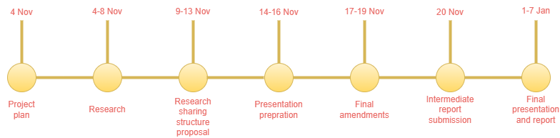

**Table 1: Timeline**

* 1. **WORK DISTRIBUTION**

Zeynep Pelin Çolak :

* Team Leader
* Designated people to specific tasks
* Analyzed similar systems
* Collected information
* Conducted interviews
* Worked on proposed structure
* Design diagram

**2.3.MEETİNG**

|  |  |
| --- | --- |
| Date | Work |
| 4-8 Nov | Searching the web for our project |
| 9-13 Nov | Adding the functional requirement seeing how they implement in the system and cheeking the rest of the project |
| 14-16 Dec | Writing the non-functional requirements |
| 17-19 Dec | Looking at examples of digrams and drawing them according to the system |
| 20 Dec | Creation of pharmacy page design content |
| 26 Dec | Adding the conclusion to our project and also checking every other millestone that we have accoemplised for our final version of this project |

1. **SOLUTION METHODOLOGY**
   1. **SYSTEM ARCHITECTURE DIAGRAM**

The human actors in this system have properties of the three characteristics of human agents of reactivity, autonomy and pro-activity. The pharmacy team can react to an increased customer demand. Each human actor involved has choices in the order they perform a task.

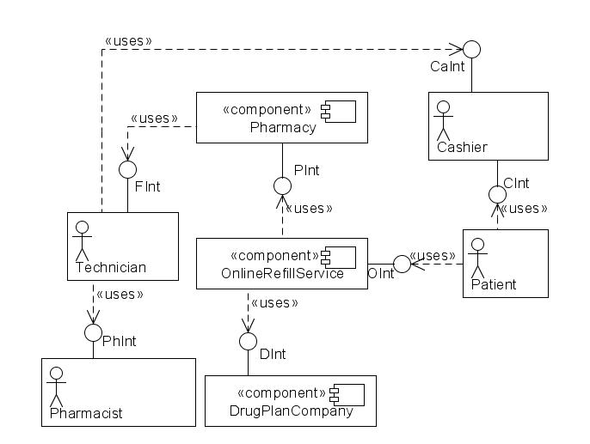

**Figure 1: System Architecture Diagram**

* 1. **Modular Hierarcy Diagram**

In the pharmacy information system, the pharmacist and the customer are the main parts of the system. The pharmacist is in charge of main structures such asmedicine management, customer management, patient management and warehouse managemet.They can add, update and do their accounting.

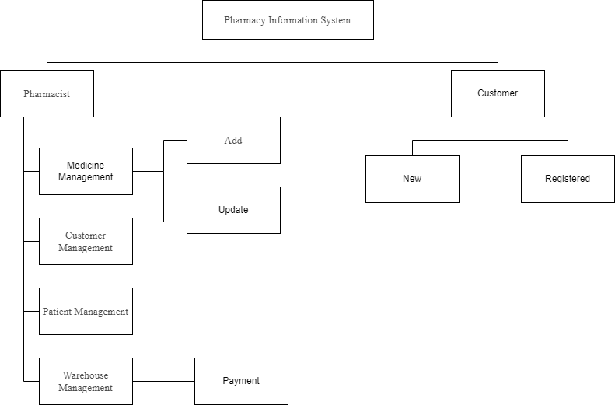

**Figure-3: Modular Hierarcy Diagram**

1. **Functional Requirement**

* Freq-1 The system shall allow pharmacist with correct login ID and password to access their account, edit and give an opportunity to change his/her password.

* Freq-2 The system will allow pharmacists to buy/order medicines. Can check if the green prescriptions are used before or prescription is original.
* Freq-3 The system shall give an opportunity to change password of users.
* Freq-4 The system shall allow pharmacists to add/delete/edit green prescriptions of the patient and message to the doctors about it.
* Freq-5 The person who involved in dispensing the drugs needs to have an eye check again, it will reduce the human error.
* Freq-6 Barcode scanning is very important in checking the correct drug, the dosage form. Also pharmacist needs to enter correct details in their system than only barcode system will work.
* Freq-7 Pharmacy software system change the alerts to hard stops, so that the pharmacist of technician can be required to stop, read the alert and type a response, ensuring that they pay attention.

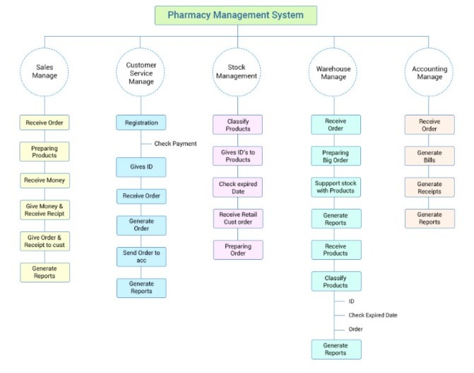

**Table2: Functional Requirement**

1. **Non-Functional / Quality Requirements**

* **Usability**

The pharmacy information system that I have developed is designed in a simple and understandable way that can be used by pharmacists and users, and it is very easy to use.

* **Reliability**

The pharmacy information system I have developed should be accessible and ready for use by pharmacists and users when requested.

* **Performance**

The software and database systems used in the pharmacy information system I have developed have the capacity to satisfy users in terms of performance.

* **Supportability**

Technical support and maintenance of the system should be easy in the web-based pharmacy information system I have developed.

* **Interface**

When the user accesses the page, he will see the home screen and will be able to see the tabs at the top. If he is a member, he will be able to navigate on the tabs within the scope of his authorization.

1. **User İnterface**

**6.1. User Login Screen**

The user will use this tab to log in to this system of which he is a member before. You can log in to the system using the username and password you have set yourself.

**Figure 3: User Login Screen**

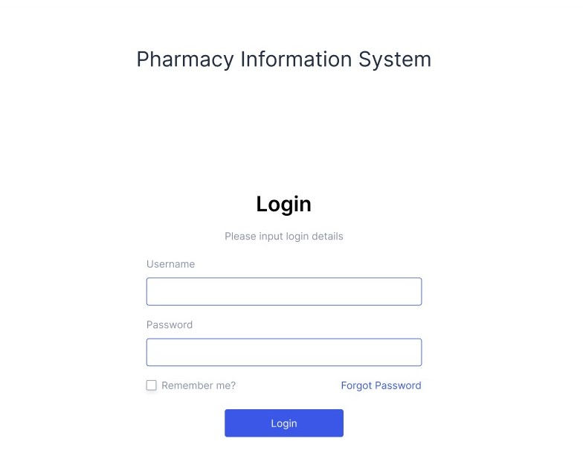

**6.2. Home Screen**

This is the page that will appear after the user logs in. As seen in Figure 4, the user will be able to access information about the drug after entering the name of the drug he wants and searching for it.

In addition, he can switch between the other tabs on the homepage and can easily see all general information from here.

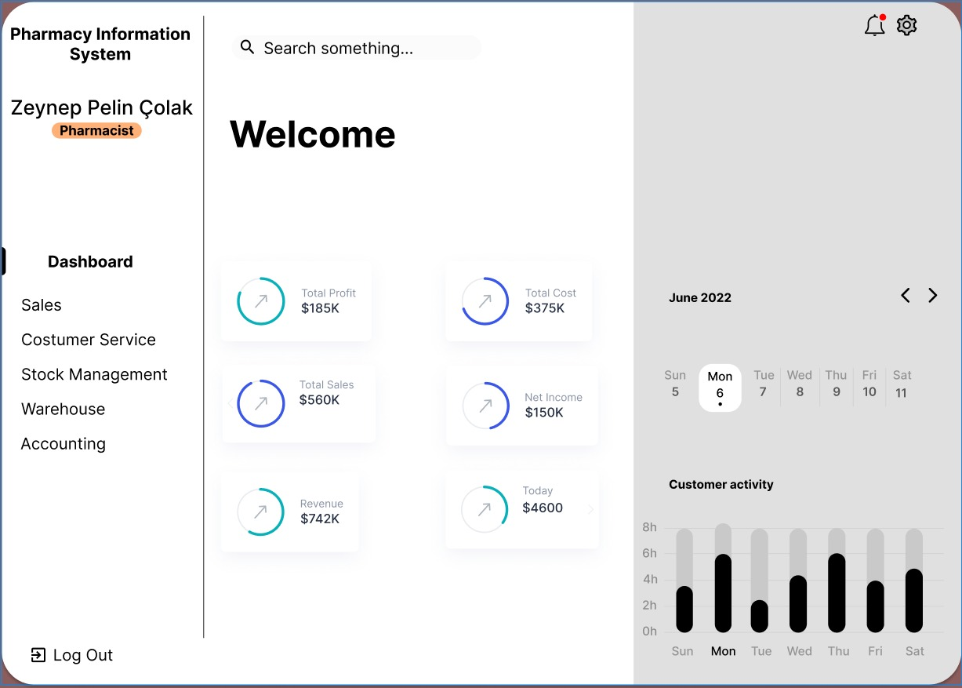

**Figure-4:Home Screen**

**6.3. Costumer Service Screen**

In the customer service tab, the customer's information can be entered and saved easily.

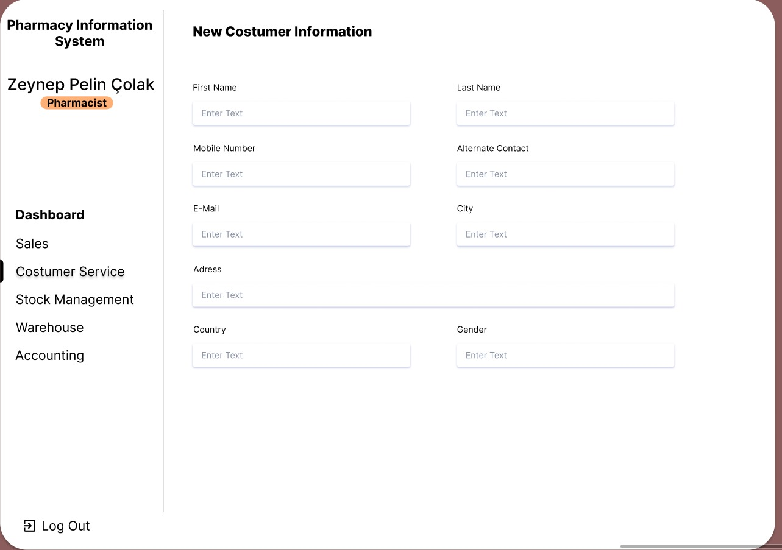

**Figure-5: Costumer Service Screen**

**6.4. Stock Management Screen**

In the Stock tab, the user can access information about the drug he is looking for. He can see how many drugs are left, price and content.

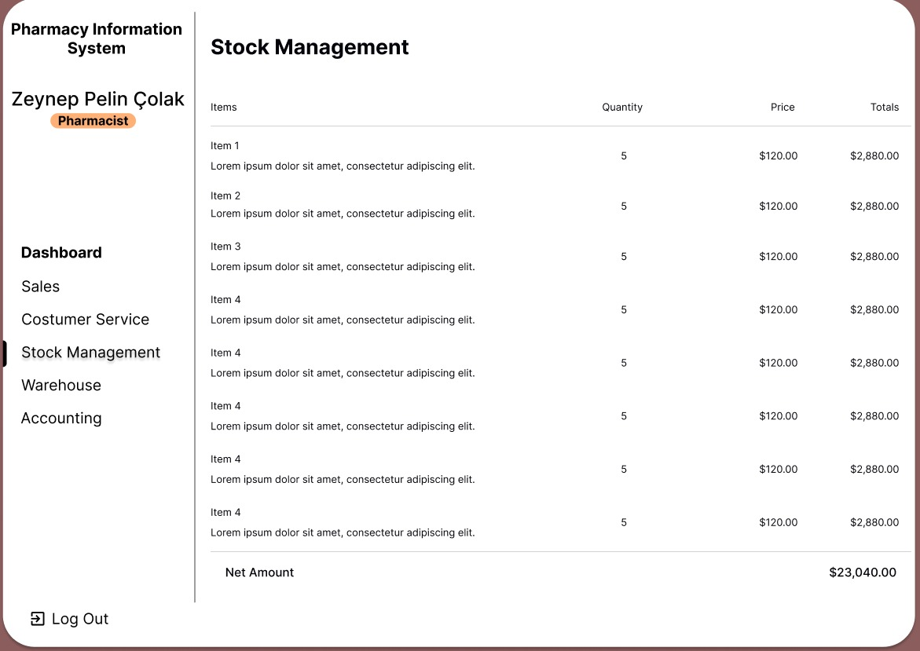

**Figure-6: Stock Management Screen**

**6.5. Medicine Information Screen**

We can see the detailed information about the drug by entering the drugs in the stock tab.

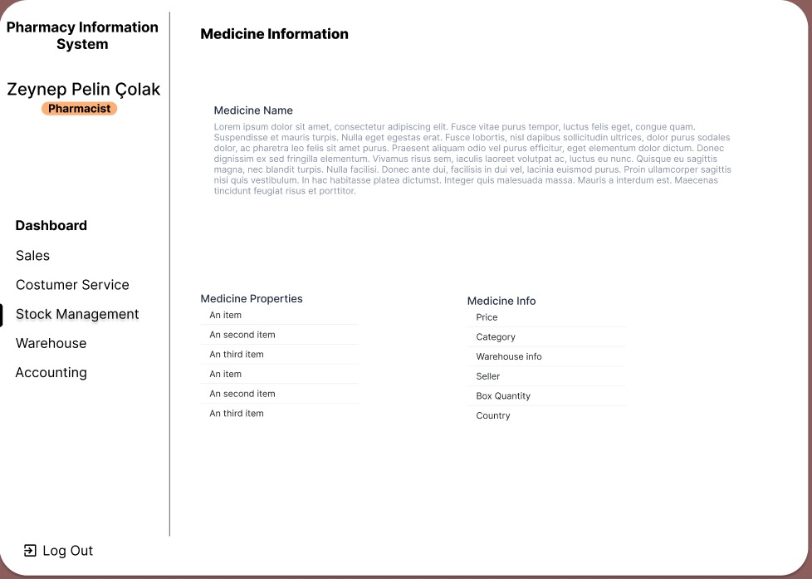

**Figure-7: Medicine İnformationScreen**

**6.6. New Medicine Add Screen**

As seen in Figure-8, the user can display the name, price, dose information, side effects, etc. of the drug he/she wants. You can add the drug by entering the information.

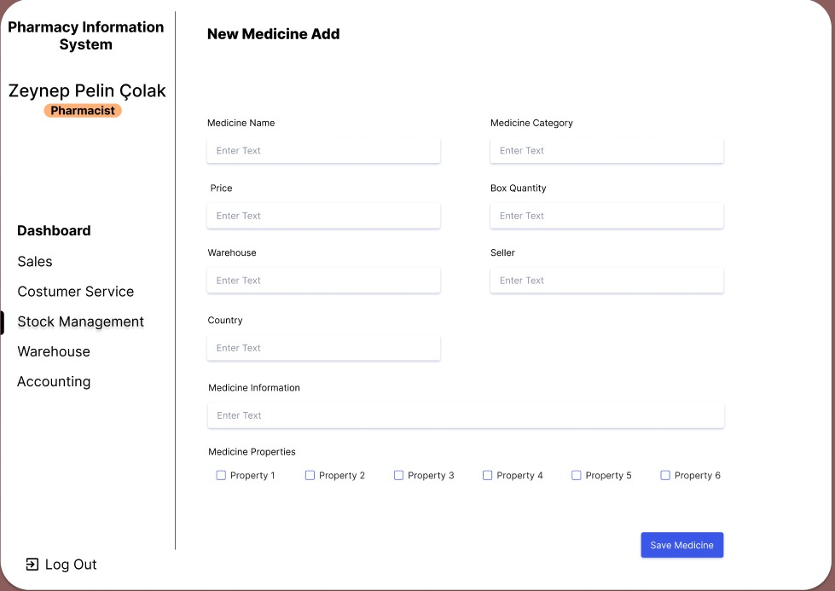

**Figure-8:New Medicine Add Screen**

**6.7. Medicine İnformation Update Screen**

As seen in Figure-9, the medication can be updated while on the medication screen.

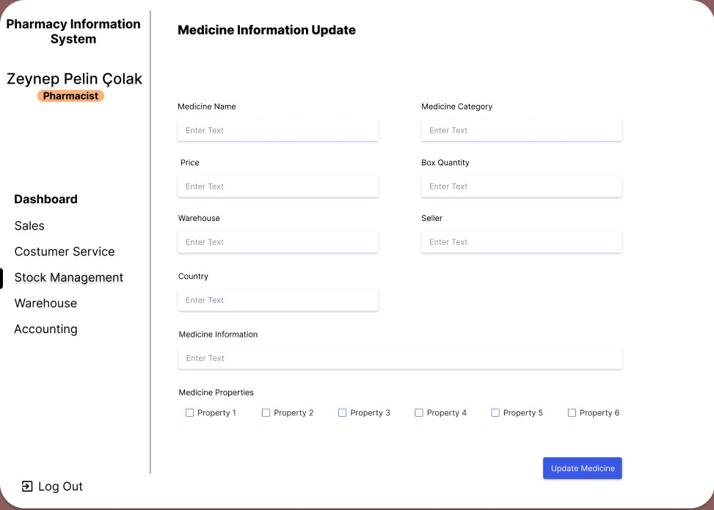

**Figure-9:Medicine İnformation Update Screen**

1. **Conclusion**

In this section, information is given about the positive and negative aspects of the pharmacy information system and the aspects that can be improved.

**Positive Aspects of the System**

It can be connected to the system from any device with an internet connection.

In order to remove security problems from there, you must be a member to log in.

It saves time.

The system interface is easy and understandable.

Provides update facility.

The system accepts returns.

**Negative Aspects of the System**

Requires basic computer skills.

Possible disconnection of internet connections.

1. **References**

**[1]** <https://jha.iums.ac.ir/browse.php?a_id=685&sid=1&slc_lang=en>

**[2]** <https://www.ncbi.nlm.nih.gov/pmc/articles/PMC4739441/>

**[3]** sciencedirect.com/science/article/pii/S2352914817301120

**[4]** <https://journals.plos.org/plosone/article?id=10.1371/journal.pone.0197469>

**[5]**<https://slideplayer.biz.tr/slide/8844161/26/images/34/Eczane+Bilgi+Sistemleri+%28Pharmacy+Information+Systems%29.jpg>

**[6]** <https://github.com/VictorOmondi1997/PharmacyInformationSystem>

**[7]** <https://synapse.koreamed.org/articles/1075799>

**[8]** <https://www.kodlamamerkezi.com>

**[9]** <https://www.codeacademy.com/learn/php>

**[10]** <https://dergipark.org.tr/tr/download/article-file/490149>